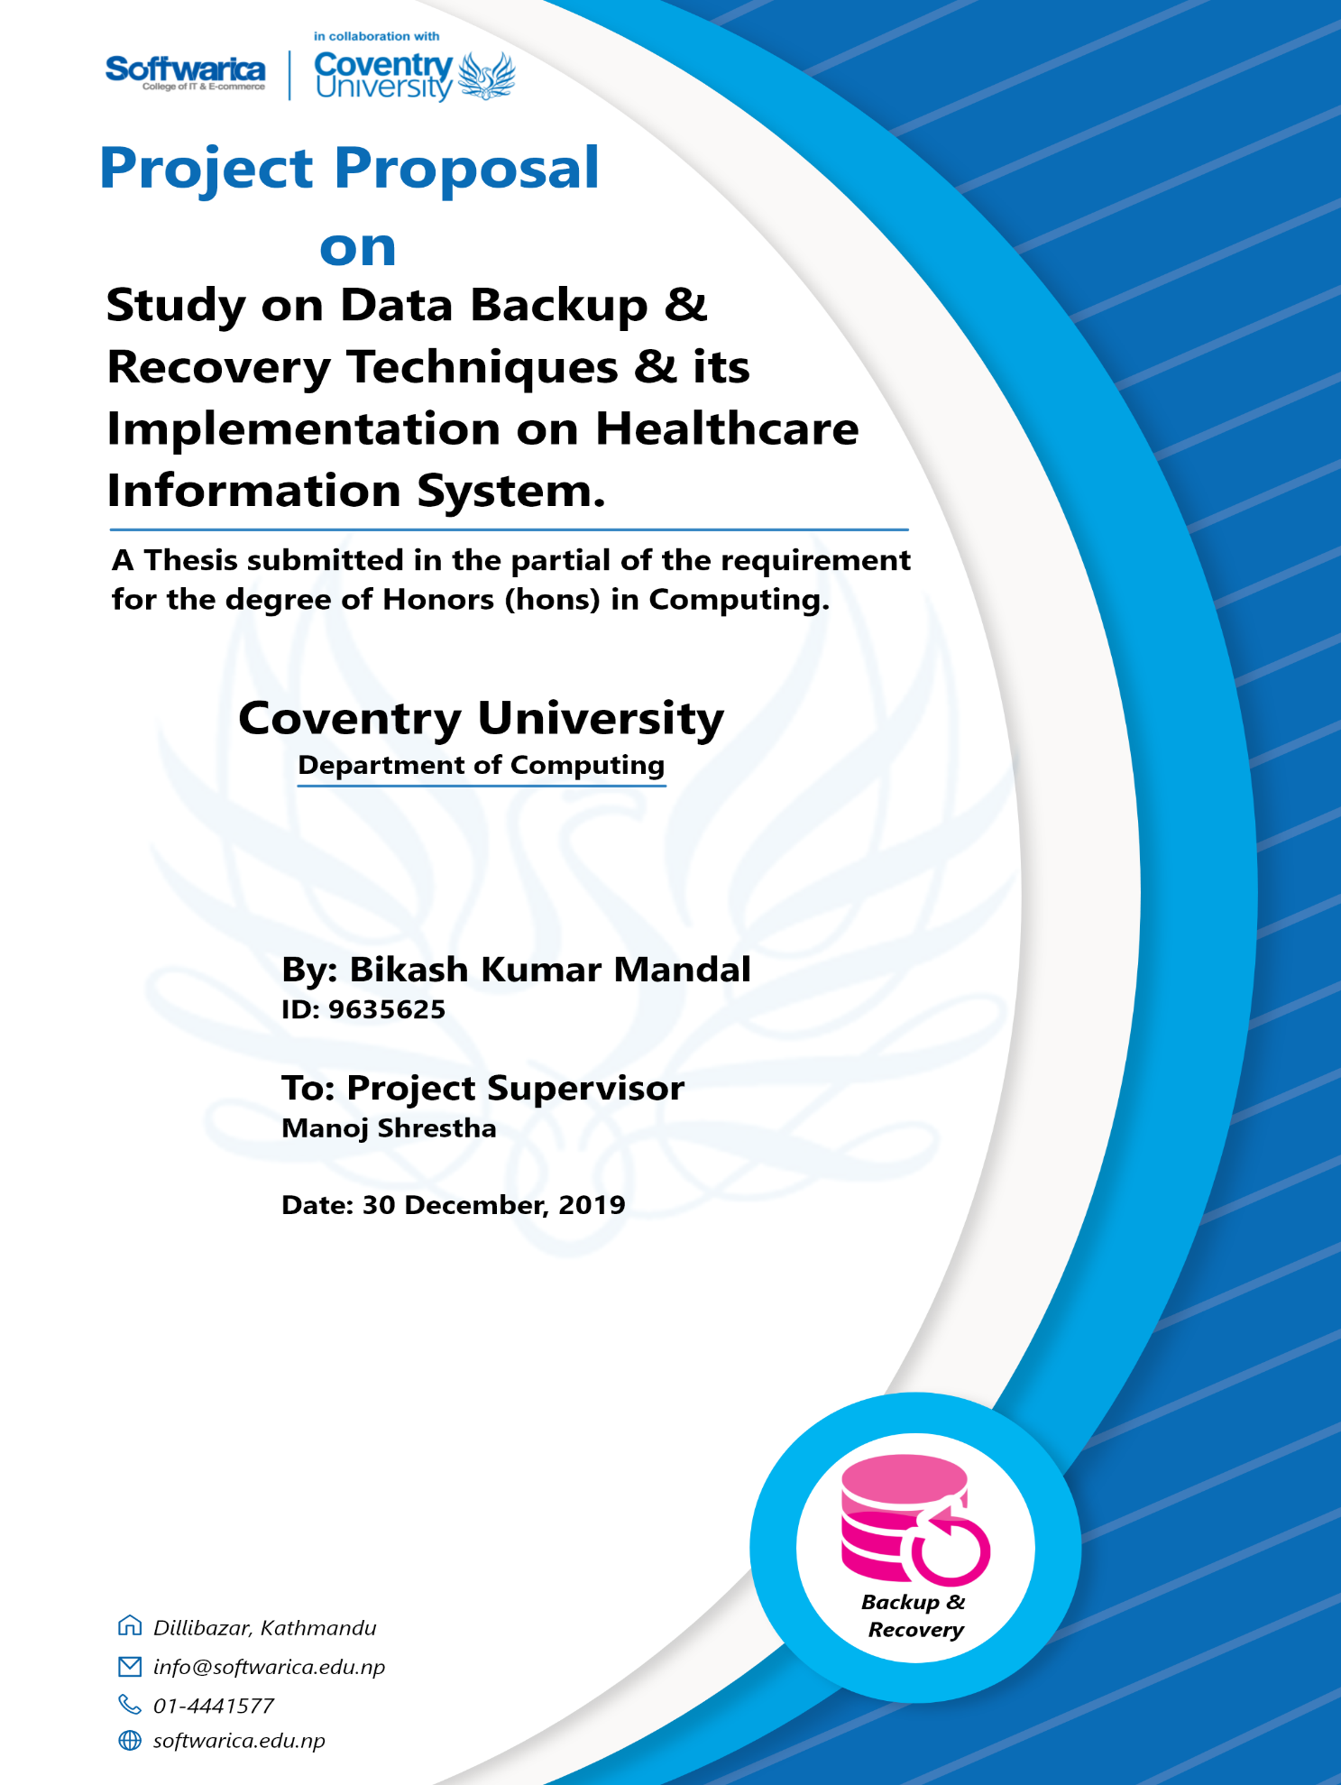

# 

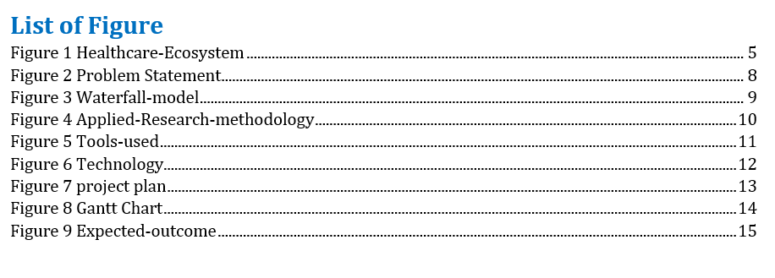

# Abstract.

Data and information security and data privacy is growing issues in healthcare sector. Healthcare data are considered as the most sensitive data for an individual. As there is increase in electronic health record and data exchange between patients and healthcare provider, all these point lead towards the implementation of batter data security. Paper based data of patients are being converted into electronic format that enables the patients to access their data online by internet. Monitoring the patients remotely become more feasible with the use of sensor paced in patient body and in home. All these data are stored in a centralized database of the hospital and there is risk of getting these data accessed by third party, data loss and database crash also increases as increase in information and technology. In this paper we explore the data privacy issues and propose a security model in healthcare that overcome the issues related to healthcare information. I described the existing methods related to data backup and recovery and discussed the issues that need furthermore consideration.

# Introduction.

Healthcare environment run through interacting processes of highly complex structure and professionals where the huge number of data and information are exchanged. With the increases in the development of technology and computer system the amount of information and data also increases which makes the application of database system in all the enterprise system, government system, E-commerce, healthcare information system and many other application systems. The demand on sharing of data and information between such system increases as well. Thus, the issue of data and information system security in every database system has become more important because most of the data and information in healthcare is not regarded public. Since the data was first recorded the threat of data loss has become concern for every company. This let us permits the concept of data backup and recovery to be performed. Useful and redundant data need to be backup and later it can be restored when any physical damage occur. As it is simple to define the data backup and recovery process, still many user lack the effective way of backing up and restoring their data.

This paper will describe the configuration of data backup and recovery technology in healthcare system. This system database will store various information and data of healthcare system. Thus, for the batter decision making and management of system the secure storage of these data plays an important role. Therefore, whenever data is accidently deleted or any physical damage occur to the database, the probability of its data recovery is zero. Common logical backup copies the data, but not physical file which makes the probability of data recovery less. To overcome such problem a real time synchronized data backup and recovery system need to be designed for healthcare system.

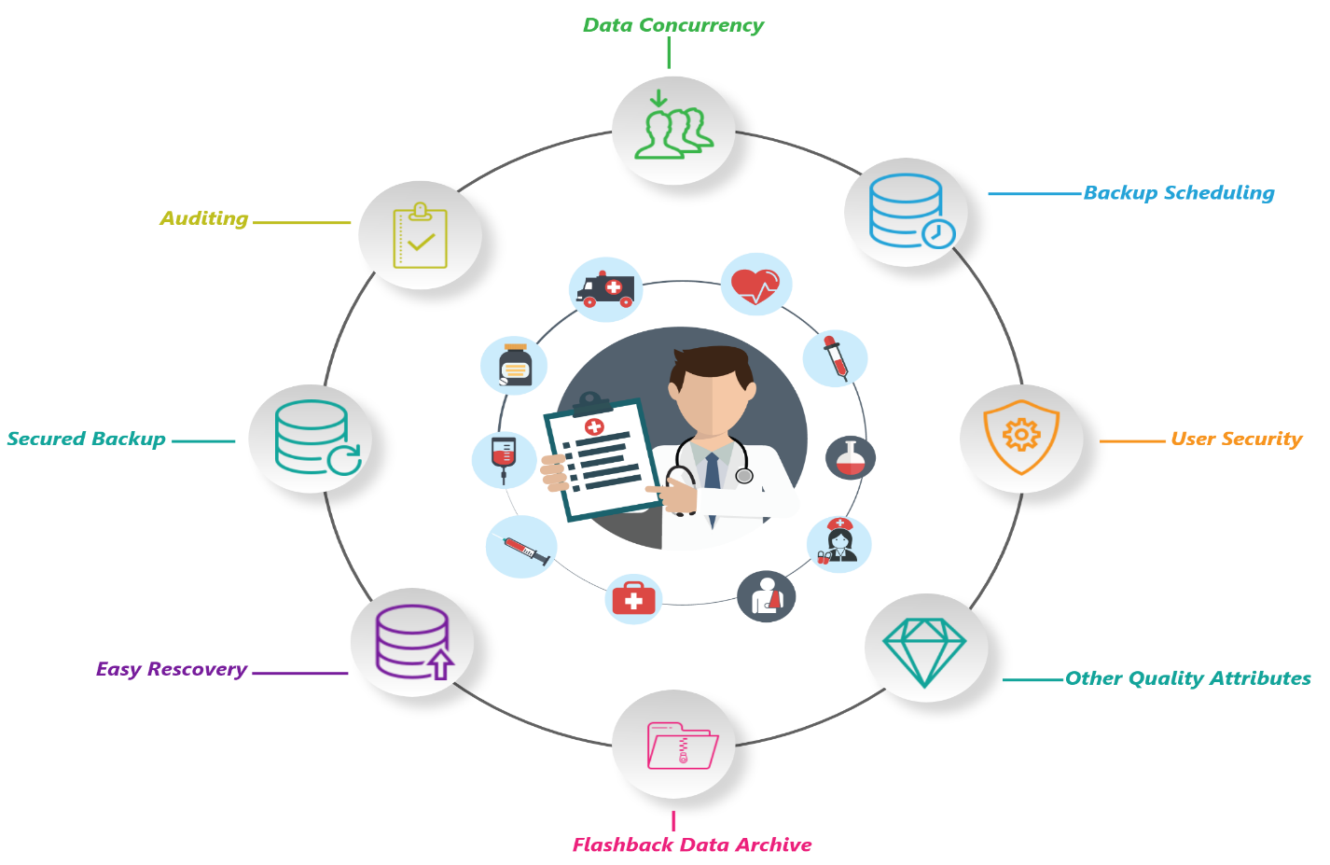

Figure 1 Healthcare-Ecosystem

# Aims.

The aim is to study and empirically explore different backup and recovery techniques and to implement the finding of study in healthcare system.

# Objectives.

* Learn various research approach.
* Identify research problems.
* Research and study various literatures.
* Identify problems in storing healthcare data.
* Learn and make use of various tools and technology.
* Design and develop database using oracle 11g technology.
* Study data backup and recovery techniques provided by oracle Recovery manager.
* Implement data backup and recovery using appropriate tools and technology.
* Automate and schedule data backup.
* Implement various security measures.
* Develop a working model of information system for healthcare using oracle database 11g.
* To test the working mechanism of the system developed.
* Stay motivated and initiative toward the work.
* Meet the set deadlines.
* Complete the research and get the degree of Honors.

# Research Question.

* Does the implementation of data backup and recovery ensure the availability of data in healthcare?
* Does automation and scheduling of data backup ensure data security?
* Does creating different user profile and roles ensure data confidentiality?

# Literature Review.

Every healthcare organization stores big amount of data about their patients, employees, medical equipment’s and for medical professional it plays an important role for them to preserve these data from getting accessed by third parties or by being deleted from the database, therefore backup of such sensitive data should be done so that whenever database get crashed or data accidently get deleted from the system then these data can be recovered from old backup copies. Thus, data security plays an important role in protecting these data and every healthcare organization must implement different security measures, rules and regulation to ensure the availability of data.

There are many researchers who have discussed about data backup and recovery including other data security measures in their research papers. Ping Yu and Nan Zhou discussed about the application of data backup and recovery in agriculture wholesale market system. He discussed that with full backup, incremental backup and cumulative incremental backup will ensures the integrity, timeliness and efficiency of data recovery when data is mistakenly deleted from the database. In his research he has used Oracle database RMAN backup and recovery technology to design and implement the backup subsystem for agriculture product wholesale market system. He also says that whenever the data in system is accidentally deleted or database get crashed then the probability of data recovery is zero or less. He also says the with common logical backups the chance of recovery of all data is less and recovery time become far from actual need, so the Realtime synchronized data backup system should be designed and implement in every enterprise system. Docs.oracle.com. (2019).

# Problem Statement.

With the increase in data and information, companies are adopting database management system to store their data. With the increase in data many companies are struggling to cope this challenge. With the increase in requirement the IT departments are forcing to improve the speed and efficiency of the system (CIS 2019). The inability to access the data is serious problem in any company. Every organization frequently face different issues related to data like data breaches, malware attack, natural disaster, user error, hardware failure and so on that makes it difficult for company to access the data when they need. Similarly, most of the companies are unware of scheduling the data backup as a result they might face problem in the time of instant recovery. Thus data backup and recovery have become critical operation for every enterprise management system requiring organization to maintain secure, flexible, speedy solution to keep access to their data all time. So, this research will focus on addressing study on backup and recovery techniques by Oracle. With the use of RMAN tool provided by oracle database which allows us to conduct full backup that backup all the data blocks within the chosen file and incremental backup which only backup those data blocks that has changed science previous backup (Connie D 1999). Techniques such as block media recovery, unused block compression, binary compression and backup encryption, backup optimization can be used to achieve data backup and recovery as a solution. Oracle.com. (2019).

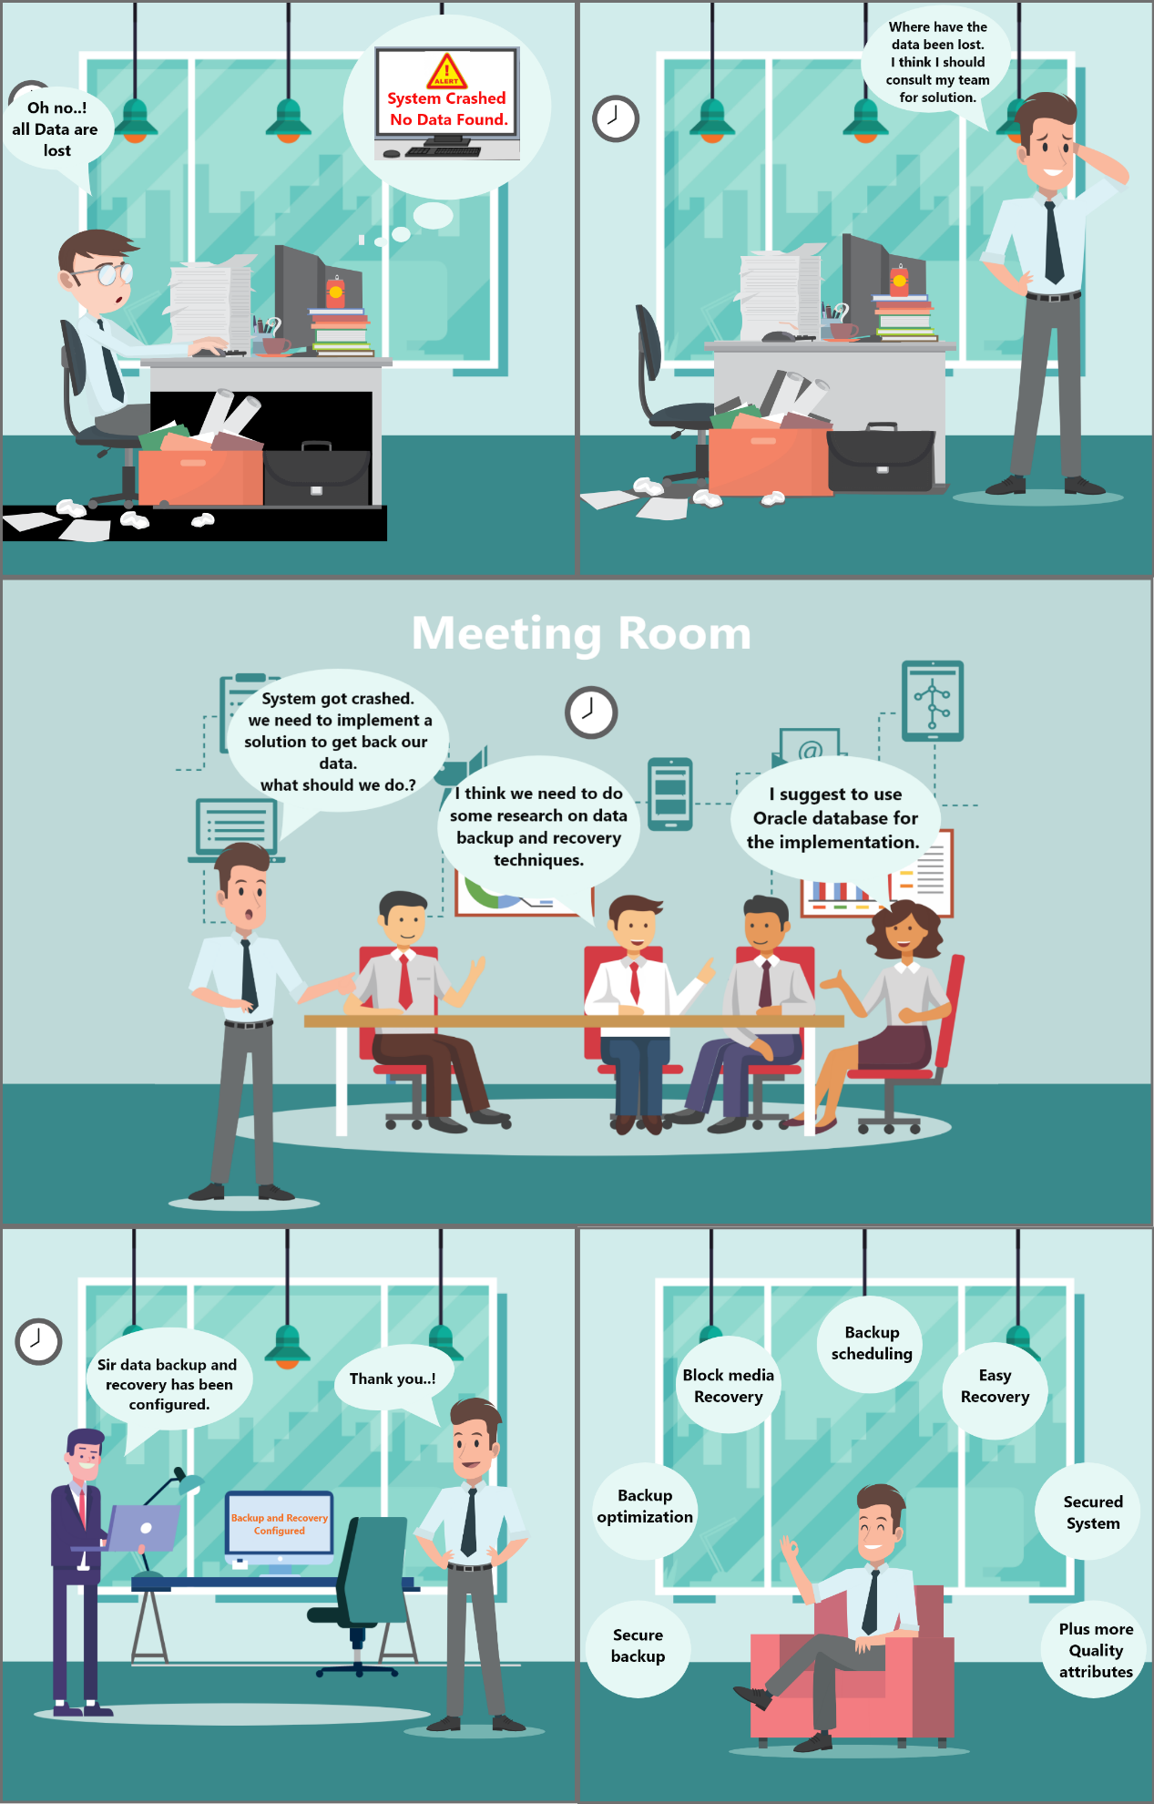

Figure 2 Problem Statement

# Development Methodology.

Waterfall methodology will be used to develop the prototype of healthcare information system. it is a linear project management method where the requirements of the project are gathered at first and a project plan is made to complete those requirements. In waterfall model it followed by requirement step to last maintenance step where one cannot return to previous phase (Ukessays 2019). As all the requirements of the project are well defined and studied, so this model can be suitable for the development of healthcare information system. following are the phase involved in waterfall model:

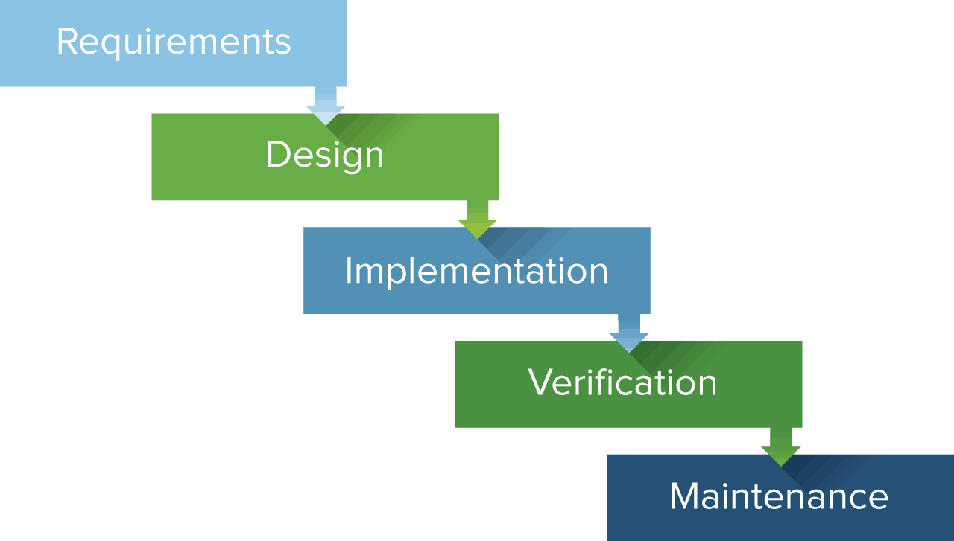

Figure 3 Waterfall-model

**Requirement:** Here all the requirements of the research are collected and listed down and prioritized according to the needs. All the tools and technology that will be used in development process are identified. All the data that lead to the development process are identified.

**Design:** the design of healthcare information system will be made which may include the type of sever architecture, database design, GUI design and all the dashboard design.

**Implementation:** All the input from design phase will be studied and integrated to develop the initial prototype of the system. Data visualization will be done to visualize the data of healthcare information system. the development of backend system is done which involve database development, backup and recovery and other quality attributes.

**Verification:** This phase is known as testing phase where all the units that are developed in implementation phase are tested. This will include the testing of database backup process, user security process and data visualization process.

**Maintenance:** this phase involves the maintenance of database. If any error or problem, occur during development we can maintain and fix such issues in the phase.

# Research Methodology.

The process of collecting data and related information of research and implementing them to make batter decision. Various techniques can be used in research methodology such as interview, survey, case study, literature study. Applied research methodology will be used as research process. It is used to solve the problem of specific problem of any individual. Such research method can be used in different areas like healthcare, business, education to identify the existing problem of that sector and find out the batter solution (John D 2019). Following are the steps involved in applied research methodology:

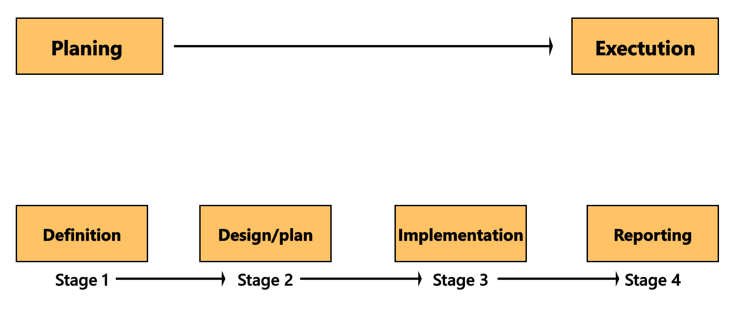

Figure 4 Applied-Research-methodology

**Definition:** All the research requirement is studied and clearly identified. All the research problems and their solution are defined in this stage of research.

**Plan and Design:** The well-defined project plan is made in order to begin the research. Tools and techniques that can be used to support the research process are identified.

**Implementation:** All the plain that are prepared in previous phase of model are executed in this step.

**Reporting:** All the finding that are gathered from the research are listed and well documented.

# Tools.

Tools that will be used for the project are listed below:

**Team Gantt:** It is web app that is used to create project gant chart and visualize project plan and schedule project task.

**Adobe Photoshop:** Photoshop is designing tool that is used to use to design, edit images, graphics.

**Abode XD:** XD is prototyping tool used for UI/UX prototyping.

**Visual Paradigm:** it is UML modeling tool used to create different UML diagrams.

**VirtualBox.** It is open source virtualization tool used to run OS virtually.

**SQL Tool.** it is command line tool to run SQL query. It I used to import and export files in database.

**Putty.** It is a tool that can be used to create SSH connection with server.

**Tableau.** It is visualization tool used in data analytics industry.

**Visual studio code:** It can be used to develop healthcare system frontend.

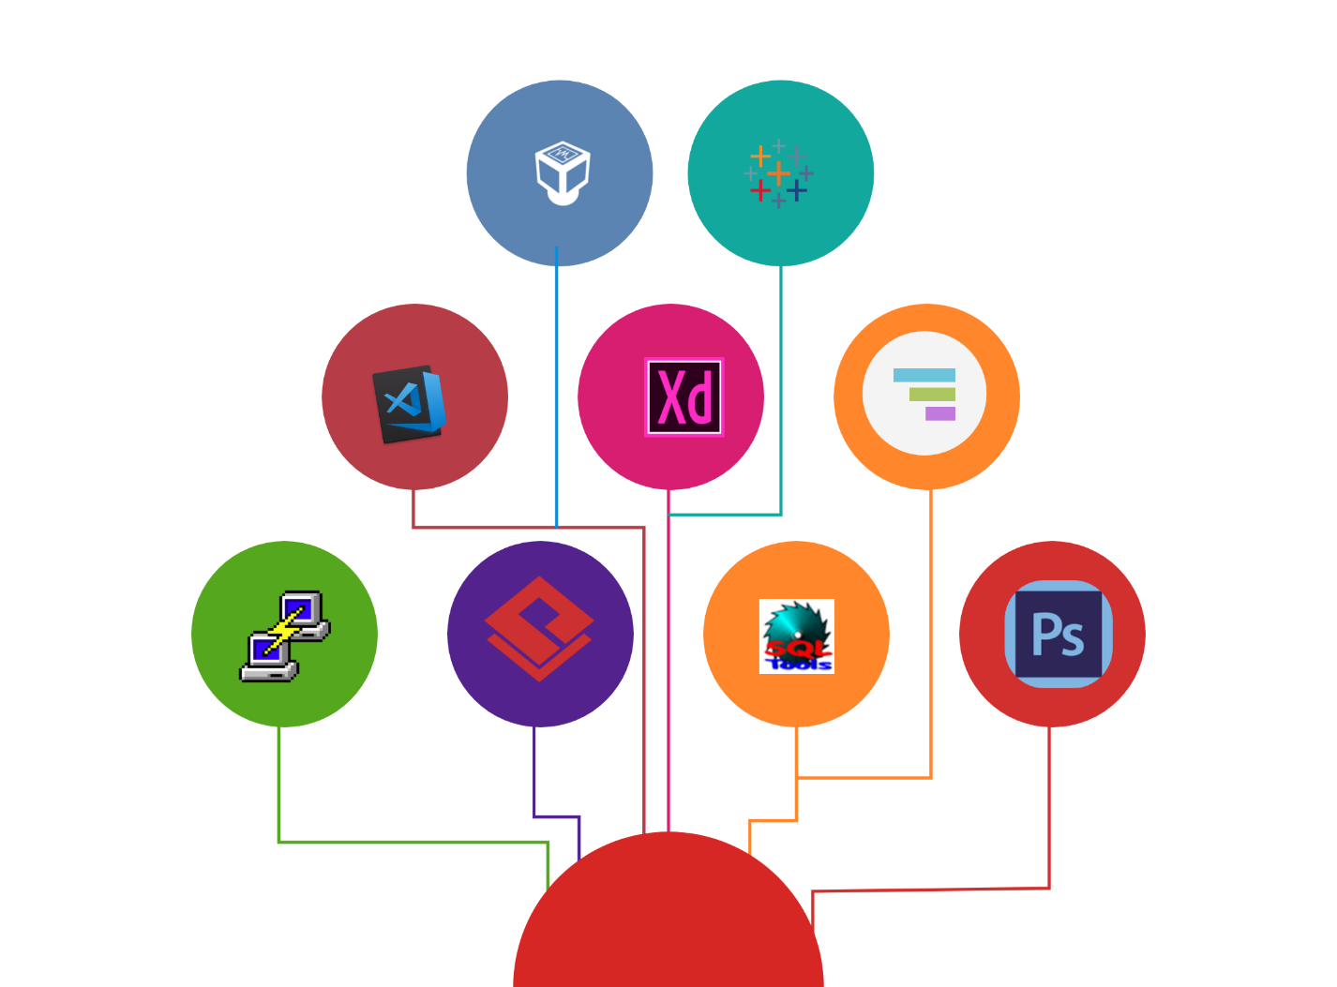

Figure 5 Tools-used

# Technology.

Technology that will be used during the project are:

* RMAN recovery manager.
* Visualization.
* Auditing.
* Automatic storage management.
* Virtual private catalog.
* User security
* Flashback data archive.
* Extraction transportation loading.
* Materialized view.
* Password verification.

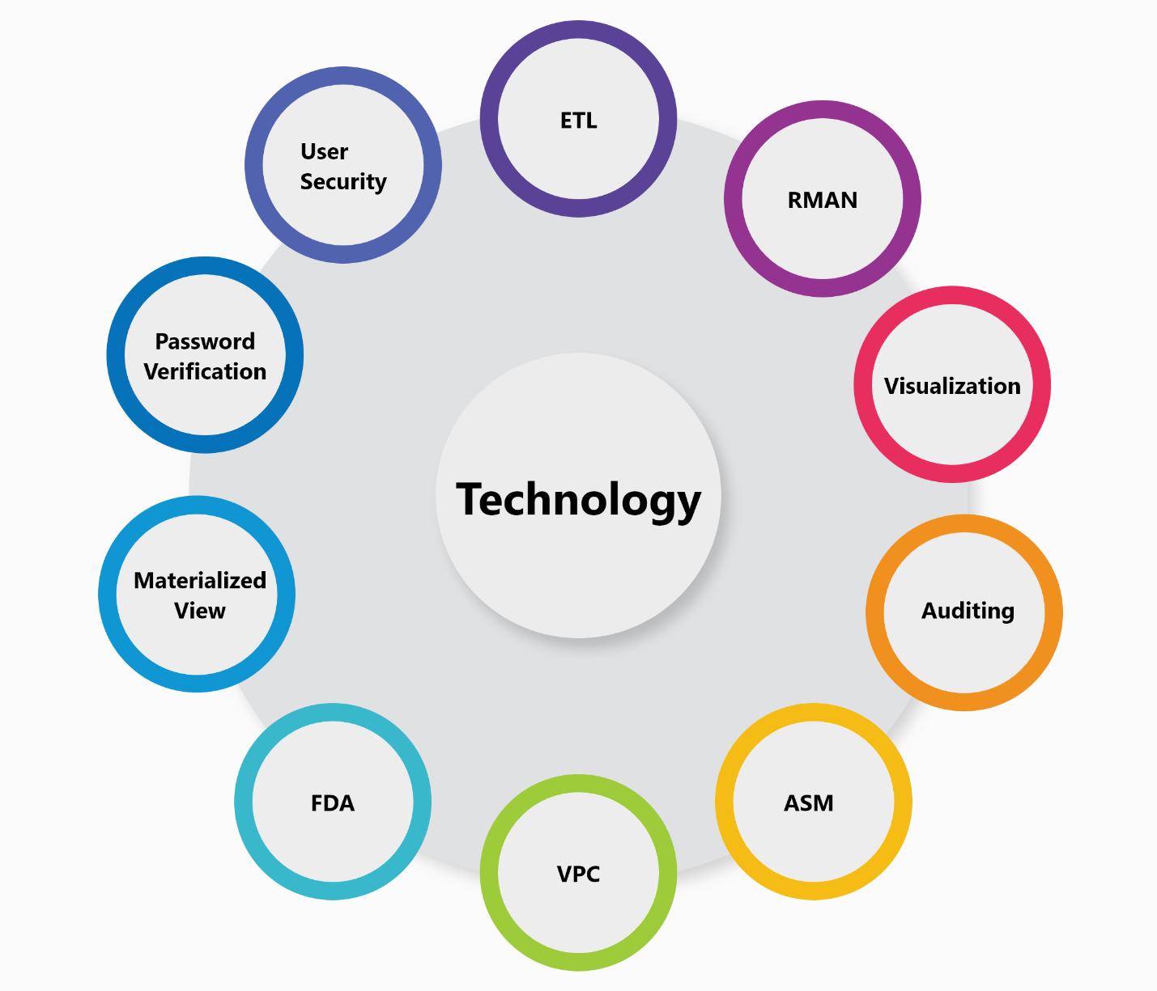

Figure 6 Technology

# Project Plan.

It is the set or list of document or spreadsheet that is used in project to track and control the task in project. Project plan ensure the successful of the project and for every project it is most important to create a project plan before starting the project. Different documents such as Gantt chart, cost plan, resource allocation plan etc. are the activity comes under project plan. Control the delivery of the project, calculate, schedule and manage the associated risk with in the project. The project plans this research paper is given below.

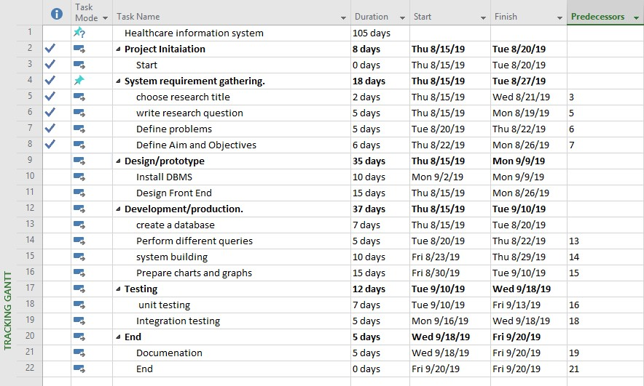

Figure 7 project plan

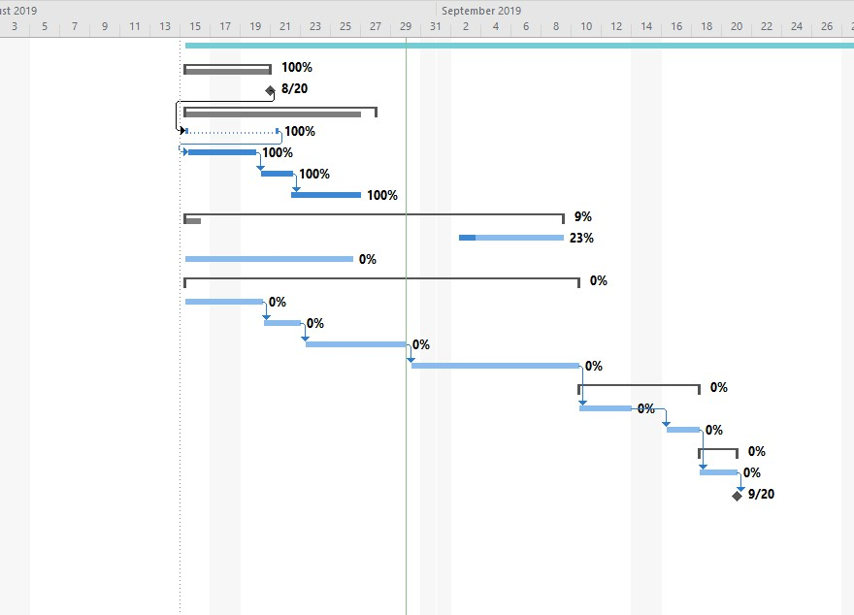

Figure 8 Gantt Chart

# Project outcome.

The expected outcome of this research is to find out the proper solution of proposed research question and implement backup and recovery solution on healthcare information system. the implemented solution will ensure the data security within the healthcare environment. The project is expected to show the importance of data security in healthcare organization. More over the project ensure data security in healthcare information system by implementing various security measures such as user security, database auditing, backup and recovery, virtual private catalog, flash back data archive, backup optimization, data visualization and some other quality attributes. Thus, the final developed system will ensure data confidentiality, integrity and data availability.

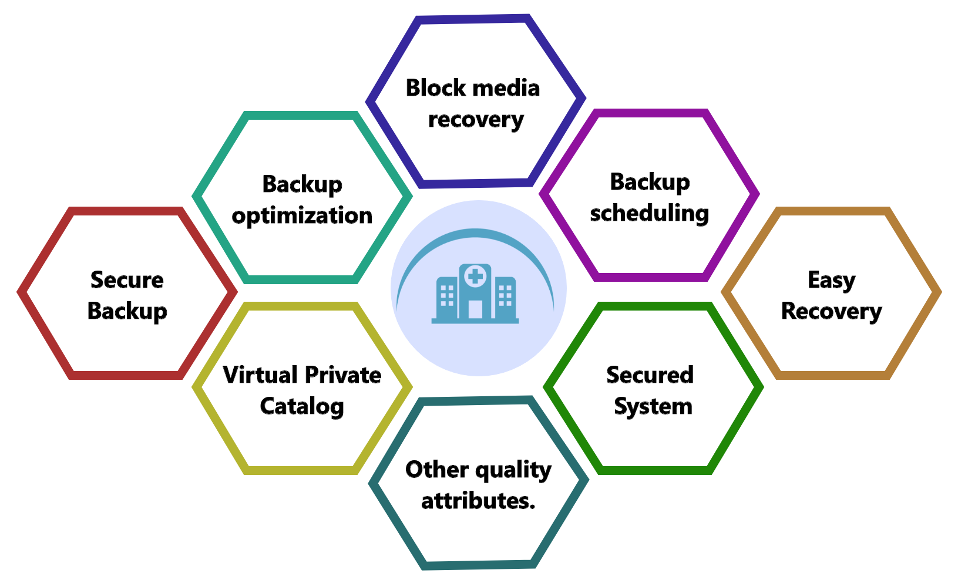

Figure 9 Expected-outcome

# Conclusion.

In this paper, the problem in healthcare data. Healthcare data contain many sensitive data about patients, medical equipment and employees etc. These data play an important role in future decision making for healthcare. The of patients in hospital Thus, if this data got lost or database got damaged then chance of getting data recovered is less. So, this research project focuses on the implementation of data backup and recovery techniques so that if database accidently get damaged then the data can be recovered from its backup. A problem statement is defined which shows what are the existing problem and the solution to those problem. We explored different research paper related to the data backup and recovery and discussed which point need furthermore consideration and look. Project development methodology is discussed which is used to control and organize the process involve in development of the project. Different tools and technology that will be used during research and development process are defined. A proper project plan is designed which is used to track and control the project.

